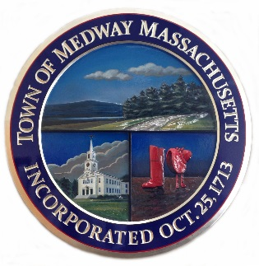

Town of Medway
155 Village Street
Medway, MA 02053

Sunshine Return Hire – Check list

Seasonal Return Form – Related Forms linked below if changes are needed
Seasonal Policy Acknowledgement
Executed CORI Form with copy of Driver’s License

Forms: https://medwayma.gov/departments/human-resources/employee-forms (seasonal)

Forms are to be returned to Human Resources at Town Hall by appointment only. Please contact HR Manager, Cheryl Houle, for an appointment after your checklist is complete.

choule@townofmedway.org
508-321-4943
Office hours: M 8-5, T 8-4, W 8-4, Th 8-4, F 8-12

